# Chapter 2 Values and Attitudes.

How Do They Affect Work-Related Outcomes?

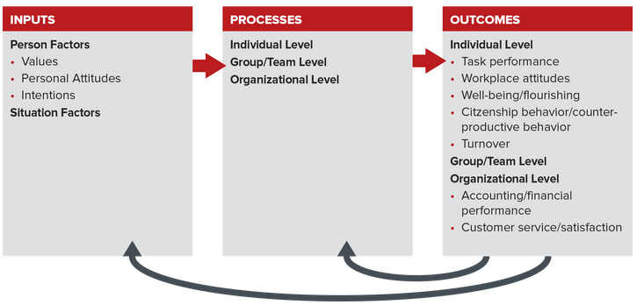

What can you do to combat bullying if you are the target?

## Section 2.1 Personal Values.

Values are abstract ideals that guide our thinking and behavior across all situations. They stem from our parents’ values, our experiences in childhood and throughout life, and our religious or spiritual beliefs. Values are relatively stable and can influence our behavior without our being aware of it.

Schwartz’s Value Theory

Schwartz proposed that broad values motivate our behavior across any context. He categorized these values into two opposing or bipolar dimensions, as outlined in Table 2.1. The first dimension ranges from concern for the welfare of others (which Schwartz calls self-transcendence) to pursuit of one’s own interests (self-enhancement). The second dimension ranges from self-directed independence (which Schwartz calls openness to change) to conformity (conservation). Schwartz stressed that it is the relative importance we give to these two dimensions of opposing values that drives our behavior.8 For example, if you value achievement (self-enhancement) over universalism (self-transcendence), you will spend your evening studying hard to get an A in this class rather than attending a meeting about fighting climate change. Our values help us to make these types of choices.

FIRST BIPOLAR DIMENSION.

Self-Transcendence Self-Enhancement.

SECOND BIPOLAR DIMENSION.

Openness to Change Conservation.

Schwartz categorized 10 broad values within these two bipolar dimensions. Figure 2.2 shows those 10 values as the slices of a pie, with the underlying bipolar dimension shown outside the circle. Schwartz located the 10 values in a circular-motivation structure to illustrate their compatibility. In general, adjacent values (like self-direction and universalism) are more compatible. That is, these values share a common focus that promotes their acceptance within an individual. Values that are farther apart (like self-direction and power) are less compatible or in conflict. Opposing values are less likely to be held by an individual.

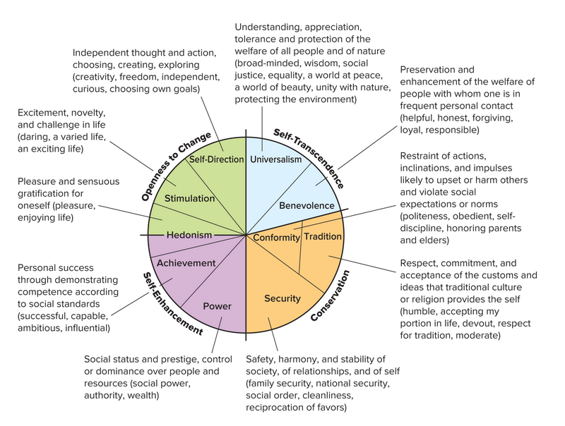

In Figure 2.2, Schwartz noted that one set of values is in opposition to the other set, as suggested by the use of color. Notice the unique treatment of several values: Tradition and conformity share a single wedge, supporting the same broad motivational goal. Conformity is toward the center because it does not conflict with the opposing value quite as much as does tradition, which is toward the outside. See also that hedonism shares elements of both openness to change and self-enhancement.

Workplace Application of Schwartz’s Theory.

Managers can better supervise workers by using Schwartz’s model to understand their values and motivation. For example, if a manager knows that an employee values universalism and benevolence, then it would be wise to assign this employee to projects or tasks that have social value. Managers can also use Figure 2.2 to reduce the chances of employees’ experiencing conflict between their values and their work assignments, when options are available. An employee who values tradition and conformity over achievement, for example, will not be happy about being asked to work on a holiday or to miss a child’s school play for work.

Managers can also reduce employee turnover by trying to reduce the gap between an employee’s values and the values that support the organization’s culture. (We discuss organizational culture in Chapter 14.) For example, an employee who wants security and tradition (two values that are part of the conservation motive) will likely be dissatisfied with a job that provides little direction and changing job requirements (two values that are part of the openness to change motive).

Personal Application of Schwartz’s Theory.

The Dynamics of Values

In general, our values are relatively stable across time and situations. This means that positive employee attitudes and motivation are greatest when the work environment is consistent with employee values. For example, outdoor gear retailer Recreational Equipment, Inc. (REI), attempts to attract and motivate employees by letting them “use kayaks, skis, and other equipment for free [which they can buy new at a deep discount].”10 The company does this because it believes that its employees are motivated to participate in outdoor activities.

Values tend to vary across generations because they are influenced by events in childhood and youth. For example, our parents lived through the Depression, which lasted through the 1930s and part of the 1940s. This experience led them to value security and to be conservative with their money. They did not like debt, and they opposed the use of credit cards. Do you know anyone with values like these? In contrast, the values held by baby boomers, people born between 1946 and 1964, are influenced by events like the assassination of President John F. Kennedy, the Vietnam War, and the shooting deaths of student protesters at Kent State University: One of the authors of this text (Angelo) attended Kent State two years after the tragic event. In contrast, Millennials, people born between 1980 and 2001, have been influenced by events like September 11, the wars in Iraq and Afghanistan, and the financial crisis of 2008. Their values are different too. We discuss generational differences thoroughly in Chapter 4.

## Section 2.2 Personal attitudes and their impact on behavior and outcomes.

Personal attitudes affect behavior at a different level than do values. While values represent global beliefs that influence behavior across all situations, personal attitudes relate only to behavior directed toward specific objects, persons, or situations. We summarize the differences between the two in Table 2.2.

Attitudes represent our feelings or opinions about people, places, and objects and range from positive to negative. They are important because they influence our behavior. For example, you are more likely to select chocolate ice cream over vanilla if you are more positively disposed toward chocolate. In contrast, workplace attitudes are an outcome of various OB-related processes, including leadership. In this chapter we reserve the term workplace attitudes for attitudes that have resulted from the interaction of various individual, group, and organizational processes. We examine the effects of workplace attitudes later in Section 2.3.

As predictors of likely behavior, attitudes attract serious attention. Hardly a day goes by without the popular media reporting the results of another effort to take the pulse of public opinion (attitudes). Political consultants use poll results, for instance, to draft messages meant to nudge the public’s attitudes toward desired results. In the workplace, managers conduct attitude surveys to monitor workplace attitudes like job satisfaction and employee engagement, and to identify the causes of employee turnover.

Personal Attitudes: They Represent Your Consistent Beliefs and Feelings about Specific Things.

Consider a work example. If you have a positive attitude about your job (specifically, you like what you are doing), you should be more willing to extend yourself by working longer and harder. This example illustrates that attitudes propel us to act in a specific way in a specific context.

Values and attitudes are generally in harmony, but not always. A manager who strongly values helpful behavior may have a negative attitude toward helping an unethical coworker.

The Three Components of Attitudes: Affective, Cognitive, and Behavioral.

Our overall attitudes toward someone or something are a function of the combined influence of three components of attitudes:

The affective component, “I feel.” The affective component of an attitude contains our feelings or emotions about a given object or situation. For example, how do you feel about people who talk on their cell phones in restaurants? If you feel annoyed with such people, you are experiencing a negative affect toward them.

The cognitive component, “I believe.” The cognitive component of an attitude reflects our beliefs or ideas about an object or situation. What do you think about people who talk on cell phones in restaurants? Your idea that such behavior is rude (or not) represents the cognitive component of your attitude.

The behavioral component, “I intend.” The behavioral component refers to the way we intend or expect to act toward someone or something. For example, how would you intend to respond to someone talking on a cell phone during dinner at a restaurant if this individual were sitting near you and your guest?

All three components influence behavior. You are unlikely to say anything to someone using a cell phone in a restaurant if you are not irritated by this behavior (affective), if you believe cell phone use helps people manage their lives (cognitive), and if you have no intention of confronting the individual (behavioral).

When Attitudes and Reality Collide: Consistency and Cognitive Dissonance.

Cognitive dissonance represents the psychological discomfort a person experiences when simultaneously holding two or more conflicting cognitions (ideas, beliefs, values, or emotions). Festinger was fascinated by the way people are motivated to maintain consistency (and avoid dissonance) among their attitudes and beliefs, and the way they resolve inconsistencies that drive cognitive dissonance. From observation, he theorized that we can reduce cognitive dissonance in three ways:

Change your attitude or behavior or both. Samantha could either (a) tell herself that she can’t help her peers because the special project is too important for the company or (b) schedule extra time each day or week to help her peers.

Belittle the importance of the inconsistent behavior. Samantha could belittle (in the sense of “make small”) the belief that she needs to help peers every time they ask for assistance.

Find consonant elements that outweigh dissonant ones. Samantha could tell herself that she can’t help because the company needs the revenue and she needs the bonus.

Attitudes Affect Behavior via Intentions

Psychologists I. Ajzen and M. Fishbein further explored the reasons our attitudes and behavior can be misaligned. Based on this work, Ajzen developed and refined a model focusing on intentions as the key link between attitudes and planned behavior. See Figure 2.3.

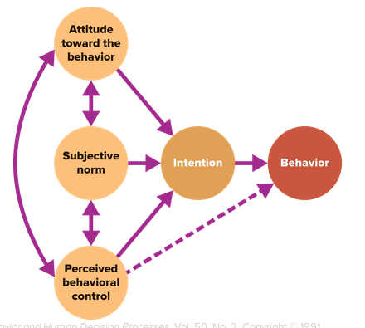

Determinants of Intention.

Putting the Theory into Practice.

Research and Practical Applications

According to the Ajzen model, someone’s intention to engage in a given behavior is a strong predictor of that behavior. For example, if you want a quick way to determine whether a worker will quit his or her job, have an objective third party ask the worker what he or she intends. The answer is likely to be accurate. Research supports this conclusion20 and the prediction that intentions are influenced by the three general motives in Ajzen’s model.

Let’s consider another practical illustration. Have you ever wanted a classmate to increase the quality of his or her work on a team project? If so, Ajzen’s model can help you. Start by trying to create a positive attitude toward contributing high-quality work. You might do this by telling the person that getting a good grade on the project will increase everyone’s chances of getting higher grades for the course and ultimately a better job upon graduation. Next, model the desired behavior by producing good work yourself and recognizing others who do the same. This should strengthen the subjective norm about doing high-quality work. Finally, talk to the individual about any obstacles getting in the way of high-quality work and discuss solutions for overcoming them. This should increase the person’s perceived behavioral control.

## Section 2.3 Key workplace attitudes.

Savvy managers will track four key workplace attitudes:

1. Organizational commitment.
2. Employee engagement.
3. Perceived organizational support.
4. Job satisfaction.

These attitudinal measures serve a dual purpose. First, they represent important outcomes that managers may be working to enhance directly. Second, they link to other significant outcomes that managers will want to improve where possible. For example, low job satisfaction and low employee engagement imply lower task performance and higher employee turnover. This is why managers should track key workplace attitudes and understand their causes and consequences.

Organizational Commitment

OB researchers define commitment as “a force that binds an individual to a course of action of relevance to one or more targets.”24 This definition highlights the way OB researchers link commitment to behavior and the way workers can commit to multiple targets or entities. For example, an individual can be committed to his or her job, family, girl- or boyfriend, faith, friends, career, organization, and/or a variety of professional associations. Let us now consider the application of commitment to a work organization.

Organizational commitment reflects the extent to which an individual identifies with an organization and commits to its goals. Committed individuals tend to display two outcomes:

Likely continuation of their employment with the organization.

Greater motivation toward pursuing organizational goals and decisions.

What Drives Organizational Commitment?

Many factors inspire organizational commitment, but let’s start with a basic one. Organizational commitment exists to the degree that your personal values match the values that pervade your company’s organizational culture. For example, if you value achievement and your employer rewards people for accomplishing goals, you are more likely to be committed to the company. This consistency between personal and company values is called person–culture fit and is discussed in Chapter 14.

Finally, commitment depends on the quality of an employee’s psychological contracts. Psychological contracts represent an individual’s perception about the reciprocal exchange between him- or herself and another party. In a work environment, the psychological contract represents an employee’s beliefs about what he or she is entitled to receive in return for what he or she provides to the organization. Research shows that an employer breach of the psychological contract is associated with lower organizational commitment, job satisfaction, and performance and with greater intentions to quit.

How Can Managers Increase Employees’ Commitment?

To highlight how managers can increase employees’ commitment, we review three general best practices and then discuss approaches used by Edward Jones, Cisco, and Google.

General Best Practices

Hire people whose personal values align with the organization’s.

Make sure that management does not breach its psychological contracts.

Treat employees fairly and foster trust between managers and employees.

Example Company: Cisco

Fortune listed it as the 70th best company to work for in 2015.

Great pay and recognition are hallmarks; 57,000 employees were recognized in 2015 for displaying Cisco’s corporate values.

Flextime helps employees achieve work–life balance. Flextime is a policy of giving employees flexible work hours so they can come and go at different times, as long as they work a set number of hours.

Five of Cisco’s largest campuses offer fitness and health centers.

Employees are given time off to volunteer, and the company matches this time with financial contributions to the volunteers’ programs.

Employees get 30 days of holiday and vacation time following one year of employment.

Employee Engagement

Observing workers at a summer camp and an architecture firm in 1990, William Kahn defined employee engagement as “the harnessing of organization members’ selves to their work roles; in engagement, people employ and express themselves physically, cognitively, and emotionally during role performance.”30 The essence of this definition is the idea that engaged employees “give their all” at work. Further study identified its components as four feelings:

1. Urgency.
2. Focus.
3. Intensity.
4. Enthusiasm.

How Much of the US Workforce Is Actively Engaged?

What Contributes to Employee Engagement?

Person Factors,

Personality.

Positive psychological capital.

Human and social capital.

Situation Factors,

Job characteristics. People are engaged when their work contains variety and when they receive timely feedback about performance.

Leadership. People are more engaged when their manager is supportive and maintains a positive, trusting relationship with them.

Organizational climate can range from positive and inspiring to negative and depleting. Positive climates obviously foster engagement.

Stressors. Stressors are environmental characteristics that cause stress. Engagement is higher when employees are not confronted with a lot of stressors.

What Outcomes Are Associated with Employee Engagement?

Consulting firms such as Gallup, Hewitt Associates, and Blessing White have been in the forefront of collecting proprietary data supporting the practical value of employee engagement. For example, Gallup estimates that an organization whose employees are highly engaged can achieve 12 percent higher customer satisfaction/loyalty, 18 percent more productivity, and 12 percent greater profitability. Other recent academic studies similarly showed a positive relationship between employee engagement, performance, and physical and psychological well-being and corporate-level financial performance and customer satisfaction.

How Can Managers Increase Engagement?

As a manager you will have many opportunities to improve employee engagement, even if you can’t offer the lavish perks of the richest corporations. One way is to make sure inputs in the Organizing Framework are positively oriented. Organizations do this by measuring, tracking, and responding to surveys of employee engagement.

Perceived Organizational Support,

Perceived organizational support (POS) reflects the extent to which employees believe their organization values their contributions and genuinely cares about their well-being. Your POS would be negative if you worked for a bad boss or a company that did not provide good health benefits or career opportunities. It would more likely be positive if you worked for The Everett Clinic in Washington. The Everett Clinic pays employees a $10,000 bonus for referring physicians, covers 100 percent of health expenses, and offers profit sharing up to 5 percent of pay.

How Does POS Affect Employees?

People are willing to work hard and commit to their organizations when they believe the company truly cares about their best interests. Quite simply, we are motivated by the norm of reciprocity to return the favor when someone treats us well. This is why we are more likely to reciprocate with hard work and dedication when our employer treats us favorably. But the favorable treatment must be voluntary, not imposed by external constraints such as government or union rules. Voluntary actions demonstrate that the giver genuinely values and respects us.

Benefits of POS,

Managers cannot go wrong in providing organizational support. Research shows that it is positively associated with employee engagement, organizational commitment, job satisfaction, organizational citizenship behavior, greater trust, innovation, and lower tendency to quit.

How can managers foster positive POS?

They can treat employees fairly, avoid political behavior, provide job security, empower employees, reduce stressors in the work environment, eliminate abusive supervision, and fulfill the psychological contract.

## Section 2.4 The causes of job satisfaction.

Job satisfaction essentially reflects the extent to which an individual likes his or her job. Formally defined, job satisfaction is an affective or emotional response toward various facets of your job. Notice that job satisfaction is not a monolithic concept. Rather, a person can be relatively satisfied with one aspect of her or his job and dissatisfied with one or more others.

Managers and organizations measure job satisfaction in one of two ways. The simplest is to use a single overall rating, such as, “How satisfied are you with your job?” People respond on a rating scale that might run from (1) very dissatisfied to (5) very satisfied. Have you ever completed a survey like this? The second method assess satisfaction along a series of facets. For example, researchers at Cornell University developed the Job Descriptive Index (JDI) to assess satisfaction with the following: work, pay, promotions, coworkers, and supervision. This type of assessment provides more detailed and actionable information about job satisfaction. If desired, managers or researchers can add the ratings across facets to arrive at a total score.

At a Glance: Five Predominant Models of Job Satisfaction.

If you want insight into the drivers of your own job satisfaction or that of others, consider five models of these causes, summarized as follows. We look at each in more detail in Table 2.4.

Brief Review: Five Predominant Models of Job Satisfaction.

1. Need Fulfillment. Need fulfillment models propose that satisfaction is determined by the extent to which the characteristics of a job allow an individual to fulfill her or his needs. Needs are physiological or psychological deficiencies that arouse behavior. All of us have different needs, which means that managers need to learn about employees’ needs if they want to increase employees’ job satisfaction.
2. Met Expectations. Met expectations represent the difference between what an individual expects to receive from a job, such as good pay and promotional opportunities, and what she or he actually receives. When expectations are greater than what is received, a person will be dissatisfied. On the other hand, he or she will be satisfied when outcomes are above and beyond expectations. Research strongly supports the conclusion that met expectations are significantly related to job satisfaction.
3. Value Attainment. The idea underlying value attainment is that satisfaction results from the perception that a job allows for fulfillment of an individual’s important values. Research consistently supports this perspective. Managers can enhance employee satisfaction by providing work assignments and rewards that reinforce employees’ values.
4. Equity. Equity theory builds on the notion that satisfaction rests on how “fairly” an individual is treated at work. If we perceive that our work outcomes, relative to our inputs, compare favorably with someone else’s outcomes and inputs, we will be satisfied. Research has strongly supported the theory behind this model. Managers thus are encouraged to monitor employees’ fairness perceptions and to interact with employees in such a way that they feel equitably treated. Chapter 5 explores how this can be accomplished.

Dispositional/Genetic Components. Ever notice that some coworkers or friends remain satisfied in situations where others always seem dissatisfied? The dispositional/genetic model posits that job satisfaction is a function of both personal traits and genetic factors. Indeed, the model implies that stable individual differences are at least as powerful as characteristics of the work environment in their impact on satisfaction.

A Shorter Walk to Work. Now that we have looked at the predominant models of job satisfaction, let’s highlight one element that allows people to balance their work and family lives: the opportunity to telecommute. Telecommuting allows employees to do all or some of their work from home, using advanced telecommunications technology and Internet tools to send work electronically from home to the office, and vice versa.

## Section 2.5 Major Correlates and Consequences of Job Satisfaction.

Thousands of studies have examined the relationship between job satisfaction and other organizational variables. We consider a subset of the most important variables from the standpoint of managerial relevance. Ten key outcomes correlate to job satisfaction, four attitudinal and four behavioral, and two organizational-level outcomes. Job satisfaction has significant correlations with:

1. Attitudes: Motivation, Job involvement, Withdrawal cognitions, and Perceived stress.
2. Behavior: Job performance, Organizational citizenship behavior (OCB), Counterproductive work behavior (CWB). and Turnover.
3. Organizational Level: Accounting/financial performance and Customer service/satisfaction.

Attitudinal Outcomes of Job Satisfaction.

We examine four attitudinal outcomes of job satisfaction that are important to OB researchers and managers: motivation, job involvement, withdrawal cognitions, and perceived stress.

Motivation.

Employee motivation represents a psychological process that arouses our interest in doing something, and it directs and guides our behavior. As you might expect, employee motivation positively correlates to job satisfaction. Managers can enhance employees’ motivation with a host of techniques and recommendations discussed throughout this book.

Job Involvement.

Withdrawal Cognitions. Although some people quit their jobs impulsively or in a fit of anger, most first go through a process of thinking about whether they should quit. Withdrawal cognitions capture this thought process by representing an individual’s overall thoughts and feelings about quitting. Low job satisfaction is believed to be one of the most significant contributors to thoughts of quitting.

Perceived Stress. Stress has negative effects on many different OB-related outcomes. For instance, it is positively related to absenteeism, turnover, coronary heart disease, and viral infections. As you would expect, it also has a strong negative relationship to job satisfaction and employee engagement. Managers should attempt to reduce the negative effects of stress by improving job satisfaction and by encouraging employees to detach from work during off-job time (stop thinking about work and don’t “take it home with you”).

Behavioral Outcomes of Job Satisfaction.

Job satisfaction has a positive association with two constructive individual-level behavioral outcomes, job performance and organizational citizenship behavior (OCB). It also has a negative relationship with two potentially negative behaviors, counterproductive work behavior (CWB) and turnover. The following discussion is more practical when you consider that these individual-level outcomes in the Organizing Framework are driven by processes at the group and organizational level, which, further upstream, are influenced by environmental characteristics.

Job Performance.

One of the biggest controversies within OB research centers on the relationship between job satisfaction and job performance. This is more complicated than it might first appear; OB experts have identified at least eight ways in which these variables are related. Here is what we know from research.

A team of researchers analyzed data from 312 samples involving more than 54,000 individuals. They made two key findings:

1. Job satisfaction and performance are moderately related. This supports the belief that employee job satisfaction is a key workplace attitude manager should consider when attempting to increase employees’ job performance.
2. The relationship between them is complex. Researchers now believe both variables indirectly influence each other through a host of person factors and environmental characteristics contained in the Organizing Framework.

Organizational Citizenship Behavior.

Organizational citizenship behavior (OCB) is defined as “individual behavior that is discretionary, not directly or explicitly recognized by the formal reward system, and that in the aggregate promotes the effective functioning of the organization.”64 This definition highlights two key points:

1. OCBs are voluntary.
2. OCBs help work groups and the organization to effectively achieve goals.

Examples of organizational citizenship behavior include such gestures as: Constructive statements about the department, Expression of personal interest in the work of others, Suggestions for improvement, The training of new people, Respect for the spirit as well as the letter of housekeeping rules, Care for organizational property, and Punctuality and attendance well beyond standard or enforceable levels.

Counterproductive Work Behavior

You already know from personal experience and OB research that the absence of satisfaction may be associated with some types of undesirable behavior, such as low employee engagement and performance. In contrast to the helping nature of OCBs, counterproductive work behavior (CWB) harms other employees, the organization as a whole, and/or organizational stakeholders such as customers and shareholders. CWBs represent a particularly negative work-related outcome. Examples include bullying, theft, gossiping, backstabbing, drug and alcohol abuse, destruction of organizational property, violence, deliberately poor or incorrect work, Internet surfing for personal reasons, excessive socializing, tardiness, sabotage, and sexual harassment.

1. EXAMPLE A Maryland man swiped 32 laptops from his nonprofit health-care employer and put them on eBay.
2. EXAMPLE A chief financial officer changed the color of the type on some spreadsheet data from black to white so as to render fake numbers invisible while boosting the totals, and his bonus.
3. EXAMPLE One regional vice president for sales billed his corporate card $4,000 for Victoria’s Secret lingerie, and not for his wife.

CWB has a strong negative relationship with job satisfaction, so managers should find ways to reduce it. Here are three key ways.

1. Hire individuals who are less prone to engage in counterproductive behavior. Cognitive ability is associated with many measures of success, so it is a logical quality to screen for in hiring decisions. Personality tests also may be relevant.
2. Design jobs that promote satisfaction, and root out and eliminate managers who treat others in an abusive manner.
3. Respond quickly and appropriately if an employee does engage in CWBs, defining the specific behaviors that are unacceptable and the requirements for acceptable behavior.

Turnover. Turnover can be a good thing when a low-performing person like George Costanza from Seinfeld quits or is fired. This result enables managers to replace the Georges of the world with better or more diverse individuals or to realign the budget. In losing a good employee, however, the organization loses valuable knowledge and experience and it can be costly. Experts estimate that the cost of turnover for an hourly employee is roughly 20 percent of his or her annual salary, higher for professional employees with specialized skills.

Job satisfaction has a moderately strong negative relationship with turnover. Managers are well served by enhancing employees’ job satisfaction, especially for high performers. For example, a survey of 20,000 high-potential employees indicated that 27 percent planned to find another job within a year.

All these considerations suggest several practical steps employers can take to tackle a turnover problem. See the Applying OB box.

